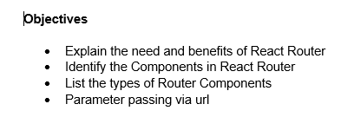

1. React Router is needed to enable navigation between different components in a single-page application without reloading the page. It helps manage URL-based routing efficiently.

Benefits of React Router are:

* React Router allows client-side routing, which enables the application to navigate between different components without reloading the entire page.
* It provides a smoother user experience by updating only the required parts of the UI when the route changes.
* React Router enables dynamic rendering of components based on the current URL, making the application more interactive and responsive.
* It helps in structuring large React applications with multiple views by offering a clear and maintainable way to handle navigation and component rendering.

1. Key components of React Router include:

* <BrowserRouter>: Used to wrap the entire application for routing to work.
* <Routes>: A container for all the <Route> elements.
* <Route>: Defines a mapping between a path and a component.
* <Link>: Used for navigation without refreshing the page.
* useParams: Hook to extract URL parameters in functional components.

1. Types Router Components are:

* BrowserRouter – Uses HTML5 history API (ideal for modern apps).
* HashRouter – Uses hash (#) in URLs, useful for legacy support.
* MemoryRouter – Keeps the history in memory, mostly used in tests.

1. We can pass parameters by defining dynamic segments in the route,

e.g.,  
 <Route path="/trainers/:id" element={<TrainerDetail />} />  
 Then, we use the useParams() hook inside the component to extract the value.

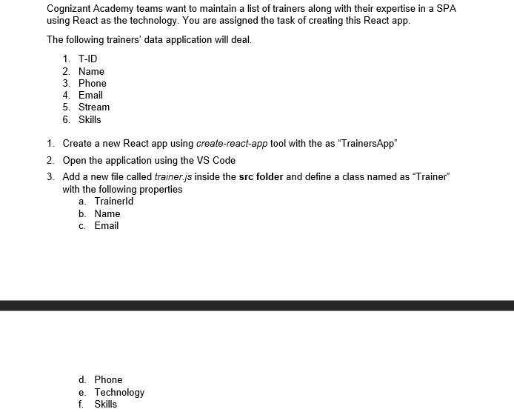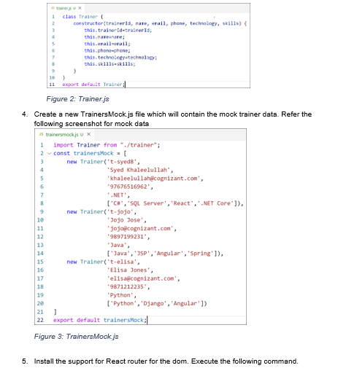

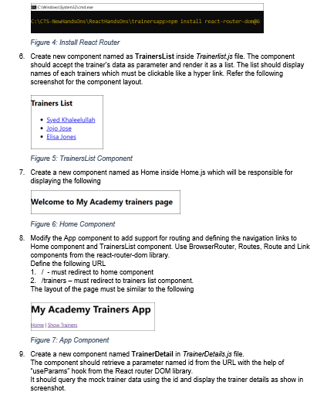

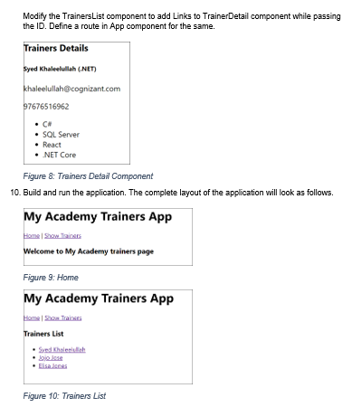

**Solution**

**trainer.js**

class Trainer {

constructor(trainerId, name, email, phone, technology, skills) {

this.trainerId = trainerId;

this.name = name;

this.email = email;

this.phone = phone;

this.technology = technology;

this.skills = skills;

}

}

export default Trainer;

**TrainersMock.js**

import Trainer from "./trainer";

const trainersMock = [

new Trainer(

't-syed8',

'Syed Khaleelullah',

'khaleelullah@cognizant.com',

'97676516962',

'.NET',

['C#', 'SQL Server', 'React', '.NET Core']

),

new Trainer(

't-jojo',

'Jojo Jose',

'jojo@cognizant.com',

'9897199231',

'Java',

['Java', 'JSP', 'Angular', 'Spring']

),

new Trainer(

't-elisa',

'Elisa Jones',

'elisa@cognizant.com',

'9871212235',

'Python',

['Python', 'Django', 'Angular']

)

];

export default trainersMock;

**trainerlist.js**

import { Link } from 'react-router-dom';

import trainers from './TrainersMock';

function TrainersList() {

return (

<div>

<h2>Trainers List</h2>

<ul>

{trainers.map(trainer => (

<li key={trainer.id}>

<Link to={`/trainer/${trainer.trainerId}`}>

{trainer.name}

</Link>

</li>

))}

</ul>

</div>

);

}

export default TrainersList;

**Home.js**

function Home() {

return (

<div>

<h2>Welcome to My Academy trainers page</h2>

</div>

);

}

export default Home;

**App.js**

import { BrowserRouter, Routes, Route, Link } from 'react-router-dom';

import Home from './Home';

import TrainersList from './trainerslist';

import TrainerDetail from './TrainerDetail';

function App() {

return (

<BrowserRouter>

<div>

<h1>My Academy Trainers App</h1>

<nav>

<Link to="/">Home</Link> | <Link to="/trainers">Show Trainers</Link>

</nav>

<Routes>

<Route path="/trainer/:id" element={<TrainerDetail />} />

<Route path="/" element={<Home />} />

<Route path="/trainers" element={<TrainersList />} />

</Routes>

</div>

</BrowserRouter>

);

}

export default App;

**TrainersDetail.js**

import { useParams } from 'react-router-dom';

import trainers from './TrainersMock';

function TrainerDetail() {

const { id } = useParams();

const trainer = trainers.find(t => t.trainerId === id);

if (!trainer) {

return <div>Trainer not found</div>;

}

return (

<div>

<h2>Trainer Details</h2>

<p><strong>{trainer.name} ({trainer.technology})</strong></p>

<p>{trainer.email}</p>

<p>{trainer.phone}</p>

<ul>

{trainer.skills.map((skill, index) => (

<li key={index}>{skill}</li>

))}

</ul>

</div>

);

}

export default TrainerDetail;

**Output**

